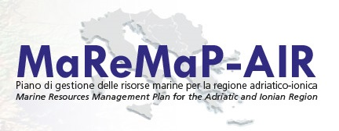

Registration Form

International Conference

Governance of the Adriatic and Ionian Marine Space

Macerata, 12-13 November 2015

Mr.
Ms.

Title ……………………………………………………………………………………………

First Name …………………………………………………………………………………….

Last Name ……………………………………………………………………………………..

Organization …………………………………………………………………………………..

Position ………………………………………………………………………………………..

Country ………………………………………………………………………………………..

Email Address ………………………………………………………………………………...

For a smooth planning of the conference, may we know which parts of the conference will you attend?
Whole conference
Only the first day (12 November)
Only the second day (13 November)

You are warmly invited to submit this form filled to maremap.air@gmail.com. Registration will only be possible until 31 October 2015.

More information will be available on the website www.unimc.it/maremap.

